TABLE OF CONTENTS
PART 1:
1. Organisational Overview & Scope
1.1 Company Overview
1.2 Scope
2. Governance & Leadership
2.1 Governance Structure
2.2 Leadership Commitment
3. Organisational Structure & Roles
3.1 Organisational Structure
3.2 Roles
3.3 RACI Chart
4. Information Security Planning
4.1 Policy & Control Planning
4.2 Risk Assessment
4.3 Training & Awareness
4.4 Resource Allocation
5. Operations
5.1 Incident Response
5.2 Documented Information
6. Monitoring & Performance Evaluation
6.1 Performance & Compliance Measurement
6.2 Internal Audit
6.3 Management Audit
7. Continuous Improvement
8. Why ISO 27001 fits AXA

PART 2:
1. Objective
2. Scope
3. Description of Dublin General Hospital
4. Identification of Crown Jewel
5. Essential Components
5.1 Infrastructure Components
5.2 Data Handling Components
6. Organisational Structure
7. Hospital Network Architecture
8. Data Handling Process
8.1 Data Collection
8.2 Data Storage
8.3 Data Access
8.4 Data Transmission
8.5 Data Backup
8.6 Third-Party Data Sharing
8.7 Data Subject Rights
8.8 Incident Response
9. GDPR Articles Mapped to each Component
10. Recommendations
10.1 Technical Recommendations
10.2 Organisational Recommendations
10.3 Documentation
11. Methods to Identify Non-Compliance
12. Exercises
13. Conclusion
References

PART 1:
1. Organizational Overview & Scope
  - Company Overview
AXA is a French Multinational Insurance Corporation that provides investment management and other financial services via subsidiaries, with operations in many continents and territories and the sensitivity of the data which the company controls(Wikipedia, 2025), the company must therefore comply with different regulations both for regulatory compliance requirements and to tackle rising cybersecurity threats.

  - Scope
The Information Security Management System Scope includes all external and internal assets relevant to its purpose of operation (ISO 27001 Clause 4.1), interested parties and their requirements that bear relevance (ISO 27001 Clause 4.2), and dependencies between activities performed by the company and those performed by other organisations (ISO 27001 Clause 4.3).

2. Governance & Leadership
2.1 Governance Structure
Board of Directors: Provision of oversight and strategic direction of Information security management system (ISO 27001 Clause 5.1)
Risk and Compliance Team: Ensure compatibility of strategic direction of the company with information security policy (ISO 27001 Clause 5.1)
Chief Information Security Officer: Ensures the integration and functionality of the information security management system into the company (ISO 27001 Clause 5.1).
IT Operation: Establishment and Implementation of process controls in accordance with the criteria (ISO 27001 Clause 8.1)
Incident Response Team: Perform information security risk assessments at planned intervals or when significant changes are proposed or occur (ISO 27001 Clause 8.2)
Human Resources: Prevents or reduces undesired effects while ensuring continual Improvement (ISO 27001 Clause 7.3).
2.2 Leadership Commitment
The Board provides resources, ensures conformity to the information security management system’s requirements and ensures the information security management system achieves its intended outcomes while being compatible with the strategic direction of the organisation (ISO 27001 Clause 5.1).

3. Organisational Structure & Roles

3.1 Organisational Structure
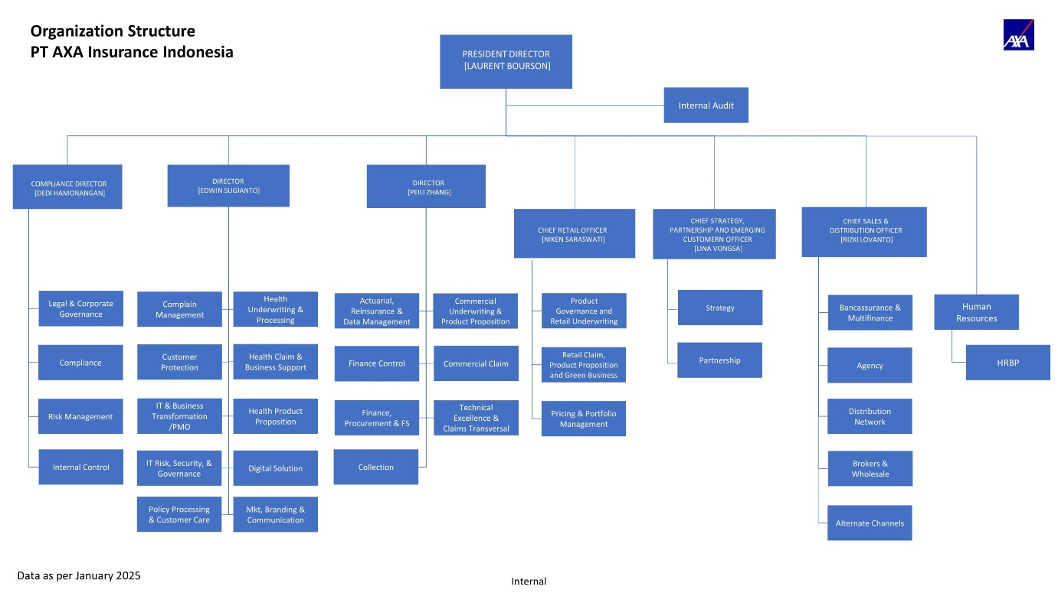
Figure 1.1 An organisational structure chart outlining the various roles of different entities present in an organisation(Hamonangan, 2025).
3.2 Roles
Role | Functionalities
President | Responsible for general oversight and strategic decision making
Internal Audit | Responsible for governance, risk and compliance management assurance
Compliance Director | Responsible for internal control framework.
Director | Oversees Finance and collections
Director | Oversees Customer care and Health Claims
Chief Retail Officer | Responsible for all retail operations
Chief Strategy, Partnership and Emerging Customer Officer | Responsible for corporate strategy, customer and partnership relationships
Chief Sales & Distribution Officer | Responsible for distribution channels and ensuring Profitability
Human Resources | Responsible for People Management

3.3 RACI Chart
Below is a table of a RACI Matrix which highlights the role of different governance structures to understand the functions of different sections of the organisation, with R = Responsible, A = Accountable, C = Consulted, I = Informed.
Function | Board | Risk & Compliance Team | CISO | IT Operation | Incident Response Team | Human Resources
Approval of Policies | A | C | R | I | I | I
Incident Response | I | I | A | C | R | I
Risk Assessments | C | R | A | C | C | I
Resource Allocation | R & A | I | I | I | I | I

4. Information Security Planning
4.1 Policy & Control Planning
Security Policies shall be approved annually by the board as part of the commitment to continual improvement of the ISMS and the Policies shall be available as documented information, be communicated properly within the organisation, be appropriate to the purpose of the organisation, and be available to all interested parties (ISO 27001 Clause 5.2), such policies may include but not be limited to security monitoring systems, encryption of sensitive data and control of access to privileged systems. The influence of the referenced article ensures the role of the board is highlighted, proper documentation is available, communicated and a scope for the policies approved are defined.
4.2 Risk Assessment
Perform well documented Annual risk assessments for critical systems and new operations of the company, evaluating the effectiveness of said actions by comparing the results of the risk analysis with the risk criteria established in ISO 27001 6.1.2 and prioritize analysed risk in terms of their critical nature to the company for risk treatment, assessment of potential consequences, realistic likelihood of occurrence of risk, the risk owners, and the level of risk acceptance criteria being measured against any potential risks to the company (ISO 27001 Clause 6.1.2), for an information security risk treatment, appropriate information security risk treatment options shall be selected taking into account the risk assessment results, all controls necessary for the implementation of the security risk treatment should be determined, the determined controls should be compared with controls present in ISO 27001 Annex A to verify the non-omission of any necessary controls, a statement of applicability which contains necessary controls, why said controls have been included, if necessary controls are included or not and the reasons for excluding any controls present in ISO 27001 Annex A, an information security risk plan should then be formed and the approval of the risk owner should be obtained(ISO 27001 Clause 6.1.3). An example of such situation would be evaluating the risk assessment of partnering up with Bank of Ireland before commencement of said partnership. The influence of the referenced article ensures the identification and documentation of potential risk for critical and upcoming operations, it also highlights the steps of an information security risk treatment plan with clear detailing on every step of the process.

4.3 Training & Awareness
Performance of annual cybersecurity and compliance training of staff present in the company, A biannual organised training session could be held for staff present in different sections of the company at different times within a specified timeline to ensure awareness of information security policies, their personal contribution to the functionality of the information security management system including the benefits of an improved Information security performance and the implications of non-compliance with the requirements of the information security management system (ISO 27001 Clause 7.3). The influence of the referenced article is to properly control or mitigate the effects of negatively impactful events.

4.4 Resource Allocation
Provision of sufficient resources by board members to enable the company achieve its intended objectives as part of the leadership and commitment requirement of the board with the allocated resources being properly documented (ISO 27001 Clause 7.1), allocation of funds to upgrade outdated software and hardware equipment present in the company could be included as one such operation. The influence of the referenced article is to clearly highlight the role of the board and to eliminate any confusion and create a paper trail on the allocation of resources.
5. Operations
5.1 Incident Response
The Company should establish and implement processes for proper operational control such as continuous monitoring of critical and non-critical systems, planned changes and consequences of any changes to the incident response operation should be properly reviewed and documented, the scope of monitoring is limited to all internal and external assets, processes, products or services relevant to the purpose of the Information Security Management System(ISO 27001 Clause 8.1). The Influence of the referenced article is to establish proper monitoring controls and to define the scope of the information Security Management System monitoring processes.
5.2 Documented Information
The Company is to ensure the organisation’s information security management system shall include documented information required by ISO 27001 and documented information determined as being necessary for the proper implementation of the information security management system, when creating and updating documented information proper identification, format and review of approval is to be conducted, documented information required by the information security management system shall be controlled to ensure availability and suitability of use, distribution, storage, version control, retention and disposition should also be closely monitored, documented information of external origin determined by the organisation to relevant for planning and operation of the ISMS shall also be reviewed and controlled (ISO 27001 Clause 7.1). The influence of the referenced article is to ensure proper creation, control and disposition of documented information relevant to the information Security Management System.

6. Monitoring & Performance Evaluation
6.1 Performance & Compliance Measurement
The Assets, policies, Processes, controls and operations needs to be outlined, documented and properly structured to outline what needs to be monitored and measured, the methods that will be used for the analysis and evaluation of said measurement, a timeline should be established for when the measuring shall be performed, the risk & compliance team should conduct the evaluation of performance, and the chief information security officer shall analyse and evaluate the results of the measurement, properly documented information shall be available as evidence of the results and the company shall make use of the results to understand the effectiveness of the Information Security Management System(ISO 27001 Clause 9.1). The Influence of the referenced article is to clarify the various details that should be taken into consideration during the evaluation of the information security management system, it also identifies clear roles for division of tasks in the various stages of the ISM system.
6.2 Internal Audit
Biannual Internal Audits should be conducted to provide information on the effectiveness of the ISMS, the internal audit should be confined to the Company’s personal requirement and the requirements of the ISO 27001 standard, the frequency, methods, responsibilities, planning requirements and reporting of the audit programme should be established, implemented and maintained by the company. the scope and audit criteria should be defined before commencement of the audit, objective and impartial auditors should be selected, results and documented information of audits should be reported to the relevant personnel (ISO 27001 Clause 9.2.2). The Influence of the referenced article is to identify and clarify the details of a regular internal audit, it helps to highlight the various elements of an internal audit and outlines the channel of information flow for the audit from the beginning to the end of the audit.
6.3 Management Audit
Biannual reviews shall be conducted by the top management of the organisation which would include actions undertaken from previous management reviews, external and internal changes that are relevant to the ISMS system, changes in needs and expectations of interested parties that are relevant to the ISMS, feedback on information security performance, interested parties feedback and any opportunities for continual improvement, the results or actions taken after the review will consist of the consideration of these various elements (ISO 27001 Clause 9.3.3). The influence of the referenced article is to clarify the timeline of a management audit, identify the relevant entities or roles and highlight the various factors which should be taken into consideration.
7. Continuous Improvement
The Company shall improve the effectiveness, clarity and efficiency of the ISMS continually(ISO 27001 Clause 10.1) through reviews and identification of nonconformities, in the event of a nonconformity the company shall react to the nonconformity by taking action or dealing with the consequences, evaluate the need for action through review of the nonconformity, understanding the cause/causes of the nonconformity and finding out if there are similar or potentially nonconformities elsewhere, any action that is needed to eliminate said nonconformity should be taken within reasonable limits, the effectiveness of the action should be assessed, if necessary changes should be made to the ISMS, documented information should be made available as highlight the presence and corrective action of the nonconformity. The Influence of the referenced article is to highlight the importance of continual improvement of the ISMS, and a stage by stage process of dealing with a nonconformity in the ISMS.
8. Why ISO 27001 fits AXA
As AXA is an organisation that operates in a highly regulated financial sector, ISO 27001 fits the organisation due to the structure and detailing that the framework provides, as the framework is trusted and implemented by a wide range of sectors such as government, healthcare and finance. The Information Security Management System provides a guideline that outlines and highlights the different security concerns of the company while outlining clear roles and tasks for different individuals or entities in an organisation.
ISO 27001 provides a standardized certified assurance for a financial company like AXA which enables the company to have a regulated standard to follow which enables the company to remain compliant and well placed in the case of any external audit or social engineering attacks.
As ISO 27001 is a framework that already protects the information of people, it also helps the company to offer a structured, auditable way to implement the technical and organisational measures that GDPR demands, thereby while not fully helping the company to become GDPR compliant by itself, it provides a solid foundational framework the company can use to become GDPR compliant(CRISC, 2025).

PART 2:
1. Objective
The Purpose of this report is to evaluate the compliance of Dublin General Hospital’s (DGH) in relation to the General Data Protection Regulation (GDPR) as applicable to healthcare organisations. The Assessment focuses on the hospital’s “Crown Jewel” asset, network infrastructure, organisational roles and data handling processes.
2. Scope
This report covers the hospital’s critical asset (Electronic Health Record System), its data flows, network components, security controls, GDPR obligations relevant to data handling, organisational roles, required activities for compliance and recommendations to ensure compliance.
3. Description of Dublin General Hospital
Dublin General Hospital is a medium sized healthcare provider that provides emergency care and 24/7 medical services. The Hospital processes Patient data, Staff records, Financial Information and external referral data. the Hospital relies on a hybrid infrastructure that consists of both on-premise servers and cloud-based systems.
4. Identification of Crown Jewel
The Crown Jewel of the Hospital is the Electronic Health Record system which contains personally identifiable information of patients, diagnosis history of patients, clinical doctor notes, medication and treatment plans. The Electronic Health Record system is the crown jewel of the hospital due to the critically sensitive data it contains, its critical availability status and the fact that it is required to make properly informed decisions about a patient.
5. Essential Components
5.1 Infrastructure Components
- Electronic Health Record Application Servers(on-premises)
- Database Servers
- Backup Servers
- Identity Management
- Firewall
- Network Switches
- Endpoint Devices
- Security Information Event Manager (SIEM)
5.2 Data Handling Components
- Authentication & Authorization
- Access Control
- Audited Logs
- Data Retention & Deletion
- Incident Response Workflow
6. Organisational Structure
Figure 2.1 An organisational structure chart outlining the various roles and responsibilities of different entities present in the healthcare sector(Anon, 2025).
Board of Directors: Provide strategic overview and direction for the organisation.
President: Responsible for the overall Functionality of the institution.
Vice President/ Therapeutic service centre: Oversees all therapeutic clinical departments within the hospital.
Vice President/ Diagnostic Service Centre: Oversees all diagnostic departments and services within the hospital.
Vice President/ Administrative Service Centre: Responsible for operational, non-clinical support within the hospital.
Vice President/ Financial Service Centre: Responsible for all financial departments and services within the hospital.
Vice President/ Support Service Centre: Responsible for all customer support services within the hospital.
7. Hospital Network Architecture
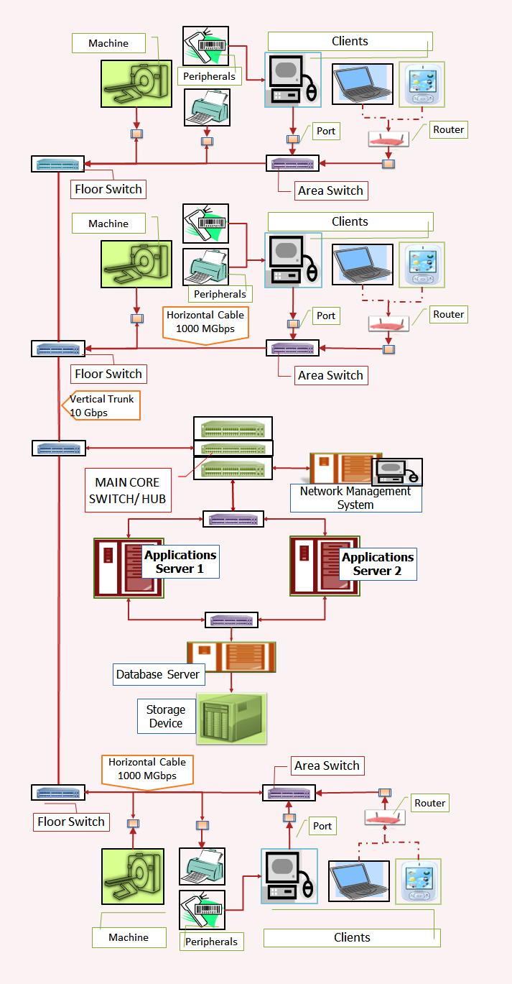
Figure 2.2 A Network hospital architecture chart outlining the various network devices and connections present in a healthcare institution(Anon, 2014).
8. Data Handling Process
8.1 Data Collection
Data gathered from the patient through patient registration, GP referrals and emergency admissions have to be gathered with relevant GDPR articles such as Article 5(1)(A) that states the lawful processing of gathered data and Article 13/14 that specifies information to be provided both in situations where personal data has been obtained from the data subject and situations where personal data has not been obtained from the data subject.
  - Data Storage
Data stored in the servers and databases of the hospital’s systems should be encrypted at rest according to GDPR Article 32 which demands security of processing of the data taking into account the nature, scope, contexts and purposes of processing as well the risk of varying likelihood and severity for the rights and freedoms of natural persons, it also demands that the controller and the processor implement appropriate technical and organisational measures to ensure a level of security appropriate to the risk including the pseudonymisation and encryption of personal data, the ability to ensure the ongoing confidentiality, integrity, availability and resilience of processing systems and services, the ability to restore the availability and access to personal data in a timely manner in the event of a physical or technical incident , a process for regularly testing, assessing and evaluating the effectiveness of technical and organisational measures for ensuring the security of the processing. and the data should be protected by design according to Article 25 which demands data protection by design and states that the controller shall, both at the time of the determination of the means for processing and at the time of the processing itself, implement appropriate technical and organisational measures, such as pseudonymisation, which are designed to implement data-protection principles, such as data minimisation, in an effective manner and to integrate the necessary safeguards into the processing in order to meet the requirements of this Regulation and protect the rights of data subjects. And that the controller shall implement appropriate technical and organisational measures for ensuring that, by default, only personal data which are necessary for each specific purpose of the processing are processed.
8.3 Data Access
Any authorized entities of the hospital that want access of the data should ensure data minimisation as demanded in article 5(1)( C ), access control should be implemented as demanded in article 32(1)(b) and records of processing activities should be properly documented as demanded in Article 30.
8.4 Data Transmission
All data that is being transmitted across the network should be properly encrypted as demanded in GDPR article 32(1).
8.5 Data Backup
Backups should be present both in local storage devices and cloud systems, the data should not be kept in a public readable format than what is necessary as demanded in article 5(1)( E ).
  - Third-Party Data Sharing
According to Article 28 of GDPR, the controller(DGH) shall use only processors providing appropriate technical and organisational measures in such a manner that processing meets the requirements of the regulation and ensures the protection of the rights of the data subject(patient), the processor shall not engage any other processor without a prior specific or general written authorisation of the controller, processing by the processor will be governed by a contract or other legal act under union or member state law, where another processor is engaged by a processor on behalf of carrying out specific processing activities on behalf of the controller, the same data protection obligations as set out in the contract being the controller and processor shall also be imposed on the processor by way of contract or other legal act under union or member state law, in the case of international transfers, the GDPR article 44-49 also provides guidelines for the transfer of data between a local controller and an international processor and states that any transfer of personal data which are undergoing processing or are intended for processing after transfer to a third country or to an international organisation shall take place only if, subject to the other provisions of this Regulation, the conditions laid down in the article are complied with by the controller and processor, including for onward transfers of personal data from the third country or an international organisation to another third country or to another international organisation. The article also states that the transfer of personal data to a third country or an international organisation may take place where the Commission has decided that the third country, a territory or one or more specified sectors within that third country, or the international organisation in question ensures an adequate level of protection. In the absence of a decision pursuant to GDPR Article 45(3), a controller or processor may transfer personal data to a third country or an international organisation only if the controller or processor has provided appropriate safeguards, and on condition that enforceable data subject rights and effective legal remedies for data subjects are available. Finally transfers are not authorised in the situation of any judgment of a court or tribunal and any decision of an administrative authority of a third country requiring a controller or processor to transfer or disclose personal data may only be recognised or enforceable in any manner if based on an international agreement, such as a mutual legal assistance treaty, in force between the requesting third country and the Union or a Member State, without prejudice to other grounds for transfer pursuant.

8.7 Data Subject Rights
A patient has the right to access, rectify, erase, restrict use and ensure portability of their data from the hospital according to GDPR articles 12-23 which provides a set of guidelines for controllers to respect the rights of data subjects.
8.8 Incident Response
According to GDPR Articles 33-34, In the event of a breach in the hospital’s network, there is a 72 hour timeline from having become aware of the breach to report said breach to relevant or interested parties such as official bodies and relevant data subjects, and in the event of a lack of notification, a reason/reasons for the lack of notification within the given time period shall be accompanied along with the notification, the notification shall describe the nature of the breach, provide contact points where more information can be obtained, describe the likely consequences of the data breach and describe measures taken to address the data breach, in the case of high risks to the rights and freedoms of natural persons, the controller shall communicate the personal data breach to the data subject without undue delay, however the communication to the data subject shall not be required if the controller has implemented appropriate technical and organisational measures that were applied to the personal data affected by the breach, the controller has taken subsequent measures which negate the high risk to the rights and freedom of the data subject and if it would involve a disproportionate effort to communicate the details of the breach to the data subject.
9. GDPR Articles Mapped to Each Component
Component | Relevant GDPR Articles | Requirement | Compliance Controls
Electronic Health Record (EHR) Application Servers | Article 5(1)(f); Article 25; Article 32 | Security of Processing | Server hardening, encryption at rest, OS patching, security monitoring
Database Servers | Article 5; Article 30; Article 32 | Security of Processing | Backup integration, Database auditing, least privilege enforcement
Backup Servers | Article 5(1)(e); Article 32(1)(c) | Storage limitation, processing resilience | Immutable backups, encrypted backup storage, retention schedules
Identity Management | Article 25; Article 32(1)(b) | Strong authentication and access control | Multi factor authentication, privileged access controls, password policies
Firewall Infrastructure | Article 32 | Protection against unauthorised access | Proper Segmentation
Network Switches | Article 32 | Security of Processing | Port security, MAC address filtering, management interface hardening
Endpoint Devices | Article 5; Article 32 | Security of Processing | patch management, secure login screens.
Security Information & Event Manager | Article 30; Article 33 | Breach Notification | Centralised logging, Log retention.
Access Control | Article 5(1)(c); Article 25 | Data minimisation, data protection by design | segregation of duties, privileged-access restrictions
Audited Logs | Article 30; Article 33 | Breach Notification | SIEM integration, immutable logs, timestamp integrity, log archiving
Data Retention & Deletion | Article 5(1)(e) | Storage limitation | Documented retention schedules, automated deletion, archival workflows, deletion logs
Incident Response Workflow | Article 33; Article 34 | Breach Notification | Incident Response Playbooks, breach notification templates, 72-hour reporting procedures

10. Recommendations
10.1 Technical Recommendations
- Enforce Multi-Factor Authentication hospital-wide
- Conduct Annual Penetration tests
- Implement logging through SIEM
- Ensure proper network segmentation between departments with least-privileged policies
10.2 Organisational Recommendations
- Conduct an Annual GDPR training to raise awareness about GDPR
- Regularly audit network access rights
10.3 Documentation
- Retain logs for 5 years or longer
- Document any incident response reports
- Ensure Secure and Strict monitoring of confidential documentation

11. Methods to Identify Non-Compliance
- Internal and external compliance audits
- Performance of Vulnerability scanning and Penetration testing
- Analysis of Logs via the Security Information Event Manager
- Testing of Backup restorations
- External party risk assessments
12. Exercises
- Incident Response drills
- Backup Recovery drills
- Staff phishing tests
- Business continuity tests
13. Conclusion
Dublin General Hospital handles critically sensitive data and therefore needs to be strictly aligned with the requirements of GDPR. The Electronic Health Record System constitutes the crown jewel of the institution and must be fully protected at all stages of data processing including data access, data storage, data transmission, data backups, sharing of data with the data subject and data processors. By following the technical, organisational and documentation recommendations present in this report, Dublin General Hospital can ensure continuous compliance and reduce any legal risks that may come with non-compliance or a data breach.

References
Anon 2025. healthcare organisational role chart at DuckDuckGo. [Accessed 16 November 2025]. Available from: https://duckduckgo.com/?q=healthcare+organisational+role+chart&ia=images&iax=images&iai=https%3A%2F%2Fimages.wondershare.com%2Fedrawmind%2Farticles2023%2Fhospital-organizational-chart%2Forganogram-of-hospital-2.jpg.
Anon 2014. Network Architecture for Healthcare Information Systems. HEALTHCARE SERVICE DELIVERY. [Online]. [Accessed 16 November 2025]. Available from: https://drdollah.com/hospital-information-system-his/system-architecture/.
CRISC, S.F., CISA 2025. ISO 27001 & 27701 vs. GDPR: Differences, Mapping & Bundling. [Accessed 16 November 2025]. Available from: https://www.strikegraph.com/blog/iso-vs-gdpr-compliance-requirements.
Hamonangan, D. 2025. Organization Structure PT AXA Insurance Indonesia.
Wikipedia 2025. Axa. Wikipedia. [Online]. [Accessed 16 November 2025]. Available from: https://en.wikipedia.org/w/index.php?title=Axa&oldid=1321975898.

